Assignment 03 - Define Effective Scope for Variables

Learning Objectives
- Learn how to explore an API and understand the business functioning
- Learn variable types defined in postman
- Learn how variable scope works
- Learn when and how to use various types of variables

Target API
https://swapi.dev/

Explore & understand Star War API
- Explore and understand Star war api developer portal: https://swapi.dev/
- Build out business entity relationship diagram in Lucidchart.
- Map out all endpoints with api names, status codes, descriptions and http methods.

Creating a collection and test structure
First of all create a collection that you can use for the rest of this section. You can find the collection in the collections navigation tree in Postman.
This API has six different resources. We could just create requests directly in the newly created collection for each of them, but that would get a bit messy. For example, the /people resource gets a list of all the people in the service, but you can also get information about specific people. If we want to be able to test different things, we will need to include several different calls to the /people resource.
Instead of creating a request for this resource, I will create a folder in the Star Wars API collection for the people resource. I can do this by clicking on the View more actions menu beside the collection and choosing the Add Folder option from that menu. I will then name that folder People. I can repeat this for the rest of the resources in this API (Films, Starships, Vehicles, Species, and Planets):
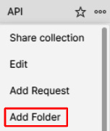
Figure 1 - Adding a folder to a collection
Now, with folders in place for each endpoint, I want to stop and think about what type of tests we are creating here. Although this service does provide a schema for the different resources that I could use to verify some of the results, it doesn't provide the kind of specification that I would need to create contract tests, so I won't worry about that kind of testing for now. I also won't worry about performance and security testing on this API. That leaves integration testing and endpoint testing. We will want to verify the various endpoints, so I will want endpoint tests. There are no direct workflows that we need to check here from a business sense, since this is just a "for fun" application, but there are still some interesting workflows that we might want to consider. For example, each of the resources cross-links to other resources. A call to a /planets endpoint gives links to people that live on that planet, along with other links. Each resource does this and provides links that point to other resources. This kind of linking creates some interesting possibilities for testing. You could check a planet's resources and see that it points to certain people, and you can check those people links to ensure that they have references to that planet. Tests like this could be a simple way to validate data integrity.
It seems like we want to create both kinds of tests, so the next thing I will do is create a folder in the collection called Integration Tests. Taken as a whole, these folders provide the basic structure for how we want to approach testing this API, but how do we organize these tests?

Organizing the tests
The first thing you need to do is to put the endpoint tests for each resource in the appropriate folder. I will start with the People folder. Click on the menu beside the folder and choose the Add Request option:

Figure 2 – Adding a request to a folder
Name the request Get All People, click on the request in the tree, and set the request URL to https://swapi.dev/api/people/. This endpoint gives back the list of all people. Each person in this list has their own endpoint, and we could create a request for each one. However, doing that could get very unwieldy. Instead, I will just sample one of the individual people endpoints. Once again, add a request to the folder and name this one Get Person Details. Set the request URL to https://swapi.dev/api/people/{{peopleId}}. Note that in this case, I have set the ID to be a variable enclosed in double curly braces. This is because I don't want to hardcode a particular value, but rather want to be able to try different characters at different times.
When it comes to organizing tests, sharing variables between them is very important. You have typed in a variable, but when you hover your mouse over it, you will see that it is an unresolved variable:
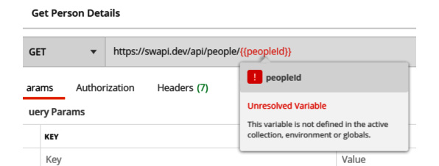
Figure 3 - Unresolved variable
This warning is here because, by surrounding it with double curly braces, you told Postman that you want to use this peopleId variable, but you have not assigned that variable any value. There are a few different places in Postman where you can store variables. The first place is in the collection itself. These are aptly named collection variables, and we will discuss them in more detail later. In this case, I want you to save this variable as an environment variable, so let's look at how we can do that now.

Environments
In order to create an environment variable, you will need an environment that you can save the variable in. You can create a new environment in Postman by following these steps:
- Click on the New button and then choose the Environment option on the resulting popup.
- Name it SWAPI Environment.
- Add a new variable called peopleId with an initial value of 1:
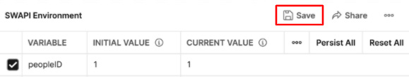
Figure 4 – Adding a new environment
- Click on Save to add this new environment and then close the Manage Environments tab.
Now that you have the variable defined in an environment, return to the Get Person Details request. The variable will still be unresolved, and that is because you need to tell Postman which environment you want to use. To do that, click on the dropdown near the top-right of the screen and choose SWAPI Environment from the list:
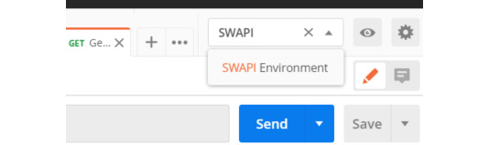
Figure 5 – Choosing an environment
Now that you have set the environment, if you mouse over the peopleId variable, you should see that it is now set to 1:
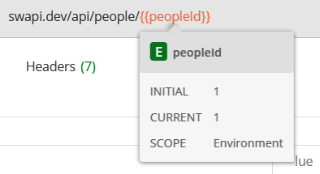
Figure 6 – Variable defined
Environments are a great way to organize data for your tests. Environments allow you to manage your variables in one place. This is very helpful if you need to make changes, or just need to understand what variables you have set up. Instead of looking through every endpoint to see what might be defined and trying to decide if you can change things in them, you can collect all the variables in one place and see what you can change at a glance.

Collection variables
I mentioned earlier that you can also store variables in the collection, so let's look at how that works. You have created a couple of requests already and each of them starts with the base URL https://swapi.dev/api. Instead of repeating that on every request that you put in the collection, let's turn it into a variable:
- Go to each of the requests that you created earlier and replace the https://swapi.dev/api URL with a variable called {{baseUrl}}.
- In the collection navigation pane, go to the View more actions menu for the collection and choose the Edit option.
- Go to the Variables tab and create the baseUrl variable, setting the initial value of it to the base URL (https://swapi.dev/api).
- Update the collection.
The variable will now be defined in all the requests that you are using it in. You can also use that variable when defining any new requests for this API.

Choosing a variable scope
You now know of two different places you can store variables in Postman (environments and collections). Since there are a couple of other places where you can store variables, but how do you decide where to store variables?
Well, in order to answer that question, let's look at the different places where you can have variables in Postman and understand how they relate to each other.

How scopes work
When you store a variable in a collection or an environment, Postman will give that variable a scope that corresponds to where you have stored it. When you're trying to resolve a variable, Postman will look for it in a defined order in each of the scopes. Scopes allow a variable to be used in broader or narrower parts of the application. If you define a variable in the global scope, you can use it in any request anywhere in the application, but if you define it at the narrowest scope, it will only be available during one particular iteration of a test. So, what are the available variable scopes in Postman? In order from the broadest to the narrowest scopes, they are as follows:
- Global
- Collection
- Environment
- Data
- Local
When resolving a variable, Postman will use the narrow scope in which that variable exists. Let's take a look at a concrete example illustrating this.
You have already created the baseUrl variable in the Collection scope. Now, we need to create a variable with the same name in the SWAPI Environment. You can do that by following these steps:
- Click on the eye icon (Environment Quick Look) beside the environment dropdown.
- Choose the Edit option to make changes to the environment:

Figure 7 – Editing an environment
- Add a new variable called baseUrl and give it silly value such as bob.
- Update the environment.
- Go to one of the requests and mouse over the baseUrl variable.
You can see that it now has a value of bob, and you can also see that the scope of this variable is Environment. Even though, in the collection, the variable with the same name contains the site URL, the value being used comes from the variable defined in the environment since an environment is a narrower scope than a collection:
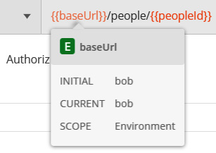
Figure 8 - Variable values coming from the narrowest scope
Don't forget to go back into the environment and clean things up by deleting the silly variable that you made! To do that, edit the environment again and then click on the X that shows up beside the variable when you mouse over the field:
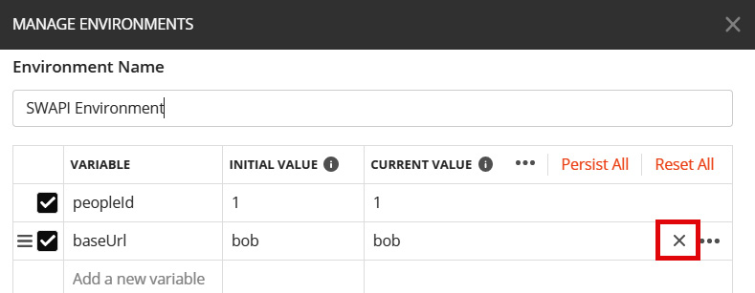
Figure 9 - Deleting a variable
You now understand how Postman determines which value to use when variables are defined in different scopes, but how do you know which scope to create a variable in? Let's do a quick overview of the different scopes and discuss when you would want to use each of them.

Global scope
The Global scope defines variables that are accessible globally or anywhere in the application.
When to use
when experimenting with sharing data between different tests or collections, but in general, you want to try and avoid using global variables. They are, by definition, available everywhere and if you use them, it is likely that you will end up eventually giving a variable in another scope the same name as the global variable. Postman will, of course, use the narrower scope, but this can still lead to confusion, especially when you're trying to debug failures.
You can add and edit variables in the global scope by using Environment Quick Look, and then choosing the Edit option in the Globals section:
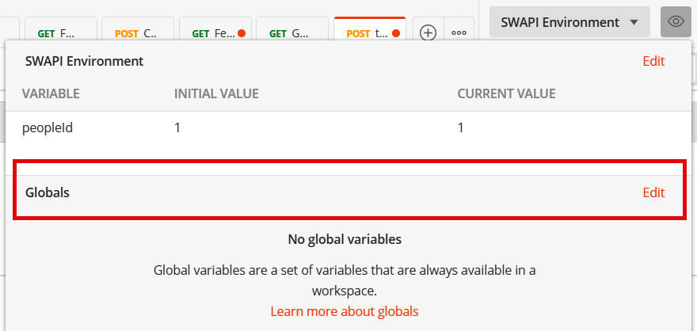
Figure 10 - Editing global variables
Variables in the global scope are the most widely available and the last ones that Postman uses when trying to resolve a variable value.

Collection scope
Variables defined in the collection are available for all the requests in that collection. They are not available in other collections, but any request in that collection can use them.
When to use
when you need to share the data between multiple requests in the collection, and that data will stay the same.
Samples
- In an application URL every request will need it, and it should stay consistent.
- when doing some setup work with a pre-request script and then storing that data in a collection variable.

Environment scope
Environments allow you to define a set of variables that belong to a certain context.
When to use
Each of these environments (different testing, staging and production sites), might require some minor changes needing to be made to the variables being used, so in these cases, you would want to create variables that live in the different environments.
Samples
Different deployment environments: If you had staging, testing, and local sites that you wanted to test against, you might define an environment in Postman for each of those sites, and then in each of those environments create a URL variable that points to the correct endpoint for each of those environments. It is important to note that in these cases, you should try not to also have the same variable defined in the collection. This will lead to confusion and is not a good practice.
Different users: If you want to try some API endpoints as different users. You might want to try as an administrator and a regular user, for example, and so you could create environments for each of those users. These will store the login information for them and maybe some specific variables that store expected results for those different users.

Data scope
In data-driven testing data is imported into Postman from a CSV or JSON file. Postman will create variables in the data scope from this imported data. You cannot create these kinds of variables yourself within Postman, but you should be aware of the kinds of variables that you have defined in your collections or environments when you are creating your input data files. The scope of data variables is narrower than that of collections or environments, so any variables defined in this scope will overwrite values defined in those broader scopes.

Local scope
The narrowest scope you can define variables in in Postman is the local scope. You can only create variables in this scope using request scripts. They are temporary variables that do not persist between sessions, but since they are the narrowest scope, they do allow you to override values that have been set in collections or environments. Sometimes, this is desirable as it lets you override a variable in one request while still using it in all the other requests in a collection.
Variables and the different scope that they can be stored in give you a lot of power, control, and flexibility when it comes to creating and organizing tests. They also help with creating tests that continue to be valuable over time.

Exercise - using variables
Hopefully, at this point, you have a pretty good grasp of the various variable scopes, but I want you to try this out, both to cement these concepts in your mind and to prove to yourself the order in which Postman resolves the scopes:
- Create a global variable called base_url and set its value to https://swapi.dev/api.
What are some potential problems with this?
- Create a new collection called jsonplaceholder.
- Add a request to that collection and set the URL of the request to {{base_url}}/todos/1.
- Mouse over the variable in the URL field.
What value does it resolve to?
- Create an environment called jsonplaceholder Env.
- Add a variable to the environment called base_url and give it a value of https://jsonplaceholder.typicode.com/.
- Go to the request you made in the jsonplaceholder collection and ensure that the jsonplaceholder env environment is selected.
- Mouse over the base_url variable in the URL.
What value does the variable resolve to? Why?
Effective use of variables is an important factor in test automation. Take some time and make sure that you understand this. Good management of this will help you create maintainable tests, but there are other factors that are important as well. Let's look at some of them in coming assignments.

